Work Instruction for Adding a Data member to Existing Persistent Objects

Written By: | RAB | Creation Date: | 5/27/2005
Reviewed By: |  | Last Revised:
Project: | PGSuper | WI # | <<#>>
 |  | Version | 1.0 - Draft

Purpose
The purpose of this work instruction is to describe things that need to be considered when adding new data members to persistent objects in PGSuper. Persistent objects include library entry objects and the various classes and structures that manage the input data.

Example
This work instruction will be in the form of an example. It will not be general purpose nor will it cover all cases. It should be sufficient to give you a very good idea of what needs to be done.

New input data
Assume we wish to add two new pieces of information to the specification library. One is a Boolean that indicates if live load deflection checks are required and the other is a parameter that represents the limiting value of deflection.

User Interface Changes
Appropriate changes will need to be made to the user interface, generally in the form of modifications to a dialog box. For this example the changes shown below were made.

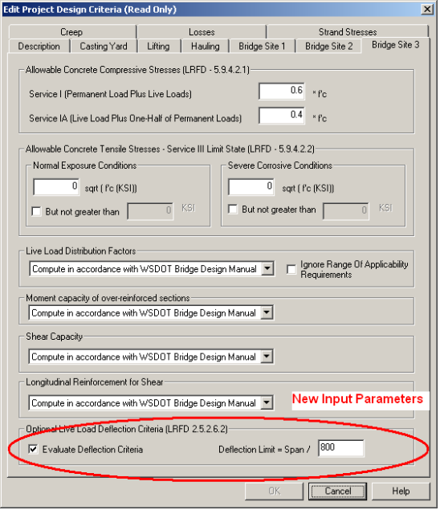

New Data Members
New data members need to be added to the SpecLibraryEntry class.
- Create new private data members. For this example they will be
bool m_bDoEvaluateDeflection;
double m_DeflectionLimit;
- Create new accessor methods (declarations shown below – definitions not shown)
//------------------------------------------------------------------------
// Determine if we want to evaluate deflection due to live load ala LRFD 2.5.2.5.2
bool GetDoEvaluateLLDeflection() const;
void SetDoEvaluateLLDeflection(bool doit);
//------------------------------------------------------------------------
// Set/Get span deflection limit criteria. Limit is Span / value.
double GetLLDeflectionLimit() const;
void SetLLDeflectionLimit(double limit);
- Update all constructors to initialize the new data
- Update copy constructors (delegated to the MakeCopy function)
- Update the IsEqual function. This function is used to determine if two library entries are exactly equal during the library conflict resolution process (if they are not exactly equal, the library conflict dialog gets displayed).
- Update the version number of the data unit for this library entry
bool SpecLibraryEntry::SaveMe(sysIStructuredSave* pSave)
{
pSave->BeginUnit("SpecificationLibraryEntry", 3.0);
…
Increment this number
- Cause the data to be saved by updating the SaveMe function.
pSave->Property("CheckLiveLoadDeflection",m_bDoEvaluateDeflection);
pSave->Property("LiveLoadDeflectionLimit",m_DeflectionLimit);
- Update the LoadMe function to load the new data and deal with missing data from earlier versions of this data unit
if ( version >= 1.6 )
{
if (!pLoad->Property("CheckLiveLoadDeflection",&m_bDoEvaluateDeflection))
THROW_LOAD(InvalidFileFormat,pLoad);
if (!pLoad->Property("LiveLoadDeflectionLimit",&m_DeflectionLimit))
THROW_LOAD(InvalidFileFormat,pLoad);
}
else
{
m_bDoEvaluateDeflection = true;
m_DeflectionLimit = 800.0;
}
Read data from file
Substitute default values if data is from an older version

